Ball State University

Another Brick in the Health Professions Building
A critical examination of the commercialization of underclassmen at Ball State University

Sophia Lyons
Senior Seminar ENG444
Ranieri
11/11/2019

A university houses an intricate hierarchy that branches off into many divisions and departments. Every aspect of a student’s university experience is departmentalized and calculated to ensure a student’s graduation throughout their academic journey. As a semi-large university, Ball State is no different. The Office of the President, Housing and Residence Life, Athletics, Academics, and the Alumni Center are all different spheres of the university. The Office of the President might oversee or direct certain goals and initiatives within these sects, but they primarily operate autonomously. Each of these departments have different goals and ways of achieving them, but there is one overarching goal that the university operates upon: retention and graduation.
The retention and eventual graduation of students inherently provides additional funds for the university through obvious fees such as tuition, but it also results in potential alumni giving. Bryan Matthew’s article “Retention Matters” for Inside Higher Ed reveals that “Significant improvement in the retention of current clients is the low-hanging fruit of revenue increases for colleges and universities” (Matthews). This is an important consideration to keep in mind as retention numbers serve as a motive for many of the objectives mentioned throughout this paper. The university operates on a business model, in which students are the consumers and the university is a corporation that provides a service. In his book Excellent Sheep, William Deresiewicz takes a critical lens to elite institutions of higher education in America and articulates the economic relationship between students and a university.
Meanwhile, policy makers had initiated an effort to transform higher education into a consumer market by funneling money to students (through grants and loans) rather than to institutions… Higher education increasingly resembles any other business now. What pays is in; what doesn’t is under the gun… “Efficiency” in the transmission of knowledge, not the unscalable craft of teaching, has become the cardinal value (67).
This quote is a fundamental consideration throughout my paper as it serves to the critical examination of how the university’s motives pervade student life in different arenas. This paper will explore the “hidden” factors and motives that shape a freshman’s path and experience at Ball State.
Context
Our senior seminar class has three student staff members that work in Housing and Residence Life. During one of our class sessions, we discussed the new emphasis on resident engagement in residence halls in the first six weeks of the school year. Studies have shown that the first six weeks of a student’s higher education experience determine their likelihood of retention and involvement within the university (Ball State Office of Institutional Research). As a student staff member that creates programming to help students socialize, get involved, and connect with their academic community, I began to think about the distribution of funds that departments receive and how they spend the money. A lot of residence hall funding comes from room and board, a fee that many university community members are critical of because of its exorbitant cost. This made me realize that many students are not aware of what their money pays for at a university.
Lens
In addition to being a student, I have held two positions within the university that have exposed me to the inner-workings and backend operations that go into the apparently “seamless” journey of an undergraduate student. I am an academic peer mentor for the Humanities Living Learning Community in a residence hall. This makes me a student staff member for Housing and Residence Life. The position is rooted in the Office of Retention and Graduation, unlike resident assistant positions, which have been institutionalized at all residence halls. APMs create department-specific programming to connect students living in a residence hall with faculty and bridge the gap between the academic aspect of campus life and their residential experience. Participation in a Living Learning Community not only correlates to a higher GPA, but also an increased likelihood of remaining in the university. More specifically, APMs have specific responsibilities that enforce retention, such as counseling students with midterm deficiencies and referring residents to different resources and offices on campus when they experience mental and financial struggles.
I have also worked as a strategic communications intern for the English department. The position involved utilizing social media, the department blog, and curating department-wide emails to increase community and engagement within the English department. Through this position, I learned about the goals of academic departments, such as major and minor recruitment. Each department wants to increase the recruitment and number of majors for better funding and class availability, which gives professors more choice in what and when they get to teach. Another fundamental aspect of intended outcomes of the position is alumni giving and outreach. Academic departments benefit from staying in contact with alumni as it can help current students learn about or get jobs in their career field, which increases the likelihood of alumni donations. When a department can quantitatively show that they are succeeding via population and career placement, it gains funding and navigational ability regarding its initiatives and functionality.
As a rhetoric major, I have learned how to deconstruct and analyze an idea or situation while considering context and implications. My education has facilitated this paper because I am able to look back on my college experience and how it interacts with the positions I have held while placing it accordingly into the way that the university functions.
Approach
To cohesively synthesize the narrative of this topic with its correlating research, I decided to create a timeline of university milestones during a student’s freshman year to clearly track Ball State’s direct involvement in the progression of freshman. Each section of this paper contextualizes the corresponding data from each milestone and synthesizes the information with the concept that Ball State functions similarly to a corporation in relation to its students and funding. 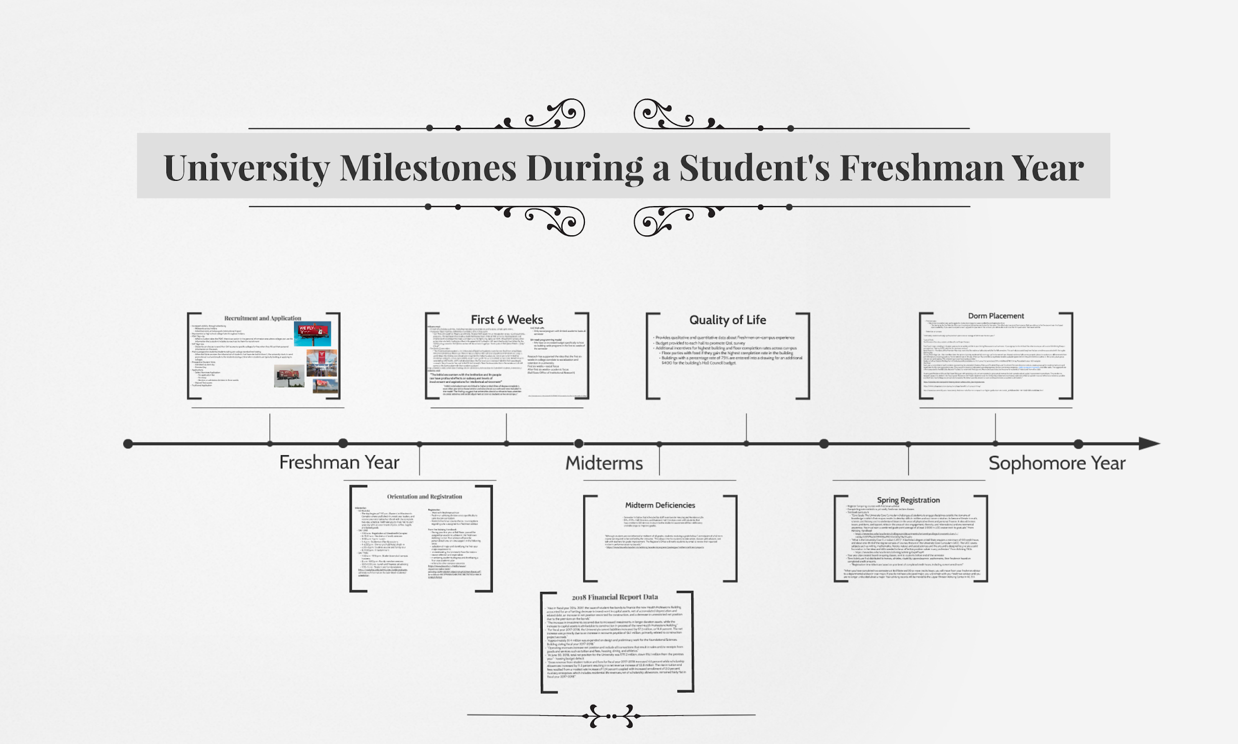
Figure 1
Recruitment and Application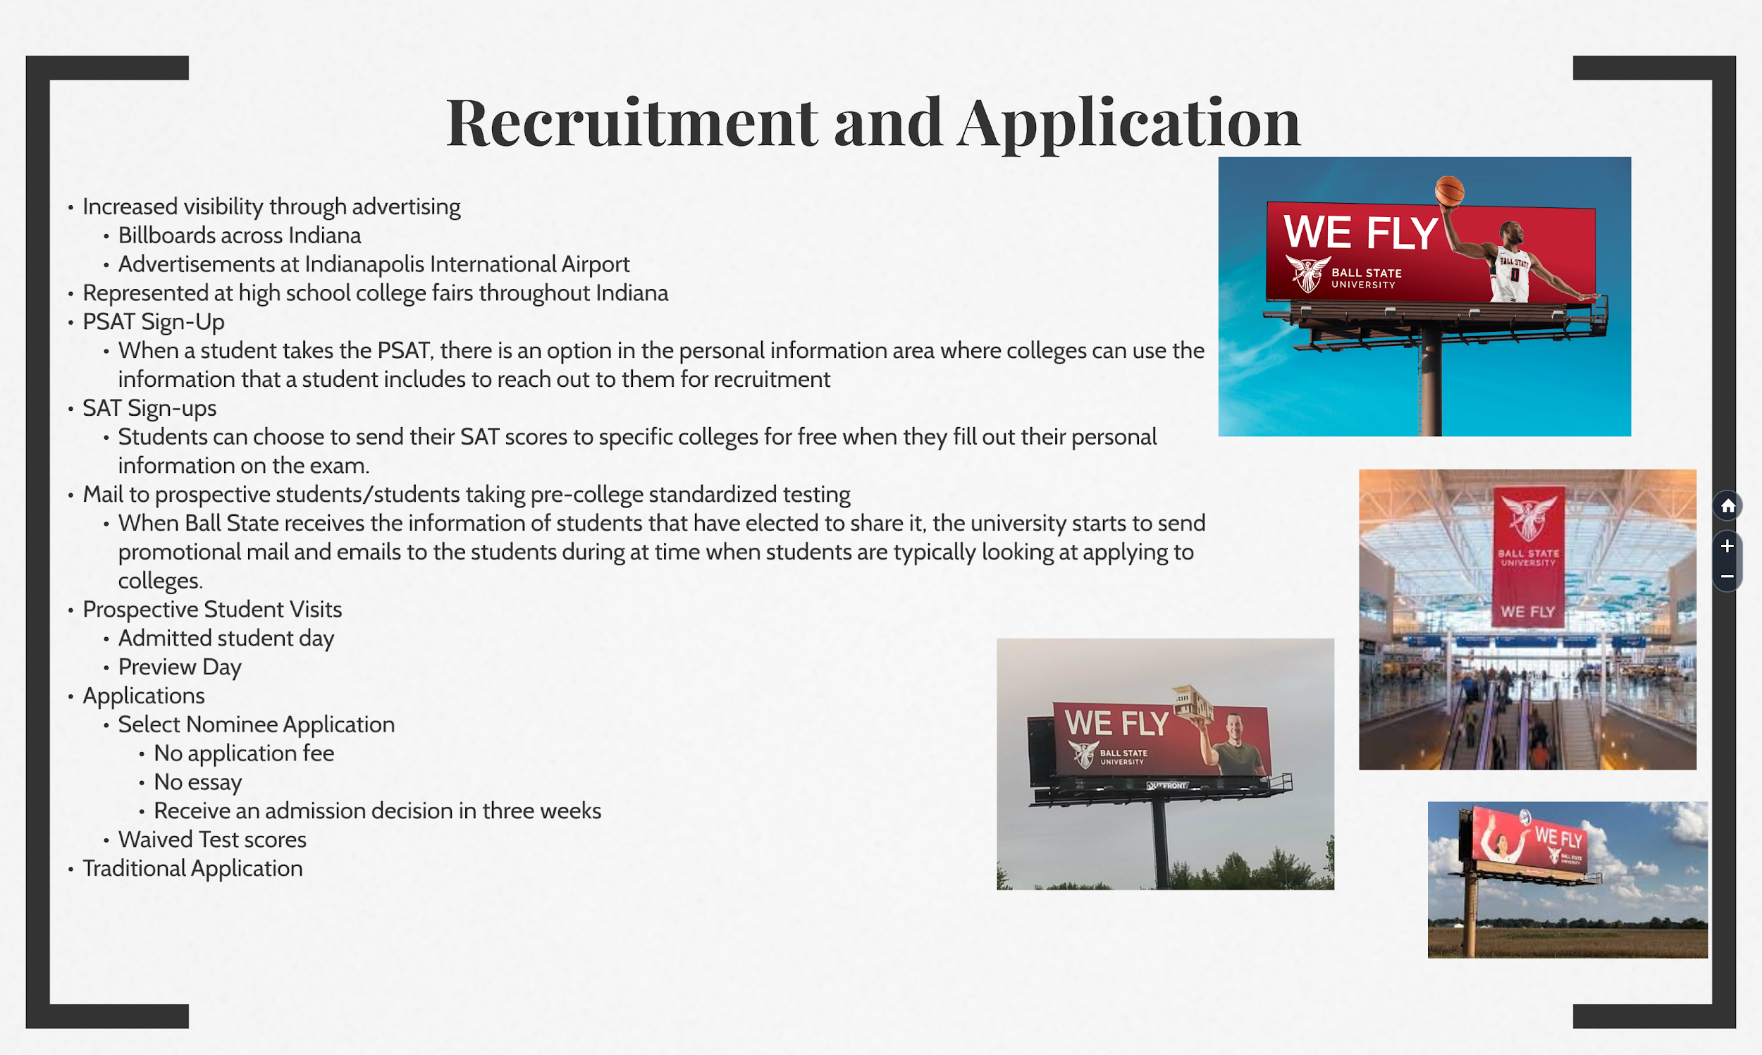
Figure 2
Before a freshman is an official student at Ball State, they must apply. When I was thinking about ways that the university commercializes students, I realized that advertising is a key aspect—especially prior to enrollment. Ball State recently rebranded and updated its advertising throughout Indiana to include the new slogan and brand-consistent imagery. The rebranding cost approximately $930,000 (Mechem), an initiative that was made in an effort to increase recruitment and, therefore, profit. But where did the university get their almost one million dollar budget from? Even if the funds did not come directly from students’ bursar accounts (like the Housing and Residence Life budgets do), enrolled students indirectly result in university revenue. Ball State utilizes myriad promotional materials and advertising methods to subliminally increase its prominence in the minds of potential applicants. Just like a corporation, the university relies on the effectiveness of its advertising to interest its consumers.
A student might then be inclined to apply after receiving significant amounts of university propaganda. Ball State has reduced the difficulty of the application process by providing different types of applications and changing merit requirements for acceptance. Ball State’s basic application is an online form with few areas that require writing. Ball State also offers a Select Nominee Application that is easier to complete and ensures an expedited acceptance decision. The Select Nominee Application is offered to high achieving high school students to encourage their enrollment and is significantly shorter than the traditional application. This incentive is meant to impact the data of high-achieving students that apply and are accepted to the university; students with high GPAs that are offered the Select Nominee Application then skew right the average GPA of students that apply and attend Ball State.
Not only is the application itself easy to complete, but university requirements have also lessened. Ball State recently waived the standardized test score requirement for applicants. According to Ball State’s website, the university has chosen to adopt a test-optional policy:
Based on our own data and research, a student’s high school GPA and high school curriculum are the best predictors of long-term student success (retention and graduation). We strive to diversify our student body as much as possible, and a test optional policy allows us to provide further access and to reach populations who might not perform well on standardized tests, but perform well in the classroom. We know that standardized testing is not the best indicator of a student’s potential for collegiate success, and we want students to feel that their application to Ball State truly shows the strength of their admission candidacy (Ball State University).
Prospective students can choose whether or not to include their SAT and ACT scores in this new application model. While a test-optional policy works toward fighting systemic discrimination and the follies of standardized testing, this adaptation also benefits the university.
The freshman class of 2023 is the largest freshman class Ball State has ever had (Ball State Office of Institutional Research) and it coincides with the first year that the university is accepting students without test scores. The new application model allows for a larger applicant pool. Despite Ball State’s increased class size, the university can maintain the same—if not smaller—acceptance ratio/percentage of admitted students because of the amount of students that apply. In doing so, the university seems more prestigious and boasts a competitive acceptance rate, while also increasing revenue from the large class size.
Orientation and Registration
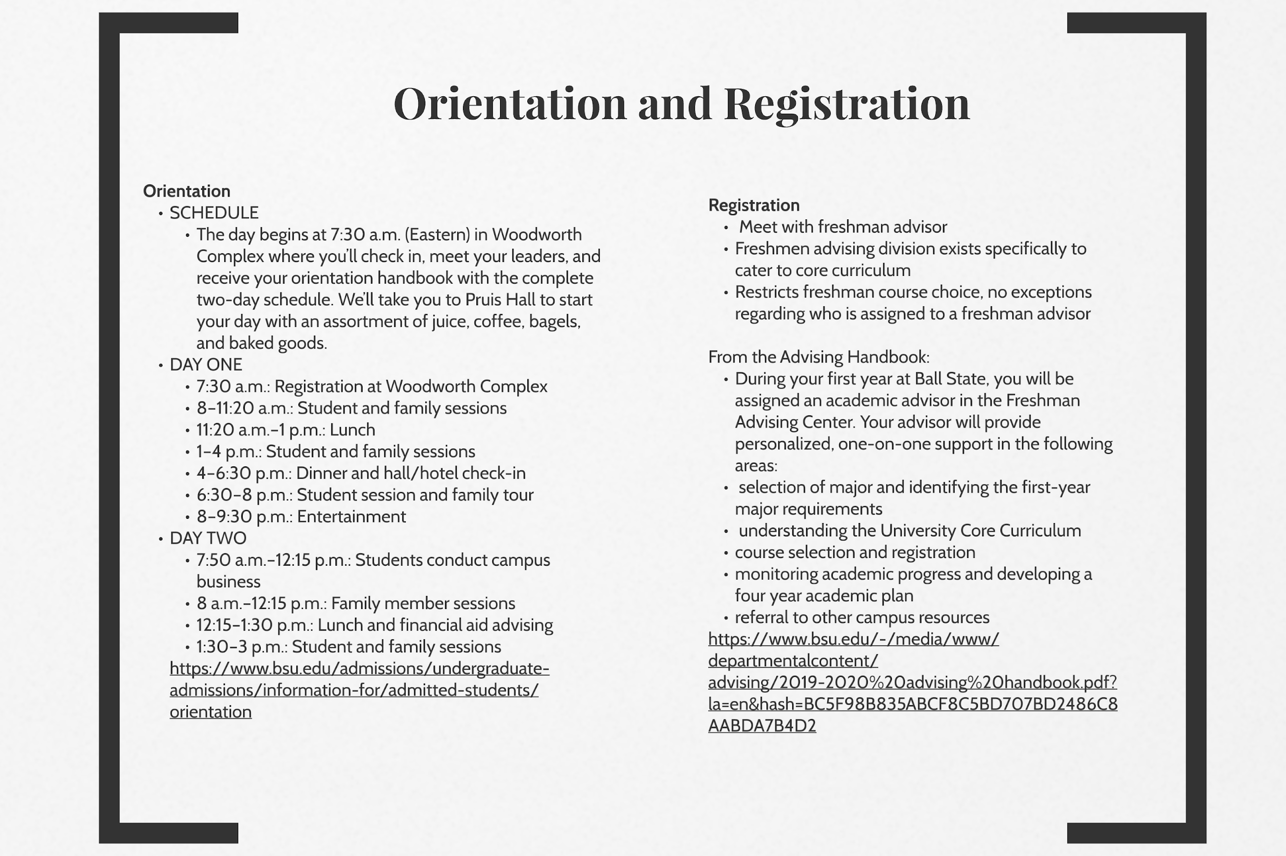
Figure 3
A student’s first intensive interaction at the university is orientation. Ball State’s freshman orientation is an overnight program that engages parents and students. Parents and students attend a variety of informational sessions that highlight the most marketable campus resources and functions. Students are permitted to stay overnight in Dehority, the honors residence hall, with an assigned roommate to presumably get a glimpse of the “college experience”. I find it interesting that the nicest dorm on campus is used for a student’s first night at Ball State. Not only does this tactic provide an optimal experience for the student, but it also subconsciously connects the luxury of the honors dorm to acceptance in the honors program, which promotes enrolling in honors. The prominence of the honors program on campus and the benefits that come with being enrolled is another marketing point that the university advertises during campus visits and orientation.
One of the agenda items for orientation is registration. Incoming freshmen meet with their freshman advisor for the first time and register for fall semester classes. Freshman advising is a particular department with rigid goals and guidelines. Advisors typically enroll freshmen in entry level classes for the university’s core curriculum. Freshmen are not allowed to work with an upper division advisor until they are registering for sophomore year classes, even if they are academically classified as a sophomore or higher because of credits. This strict process is to ensure that core curriculum is completed, which prevents an obstacle to graduation once a student is a senior. The university structures its outcomes in departments and sects throughout the institution to improve its graduation rates, which is a helpful statistic to utilize when trying to gain funding through grants, advertising, etc.
First Six Weeks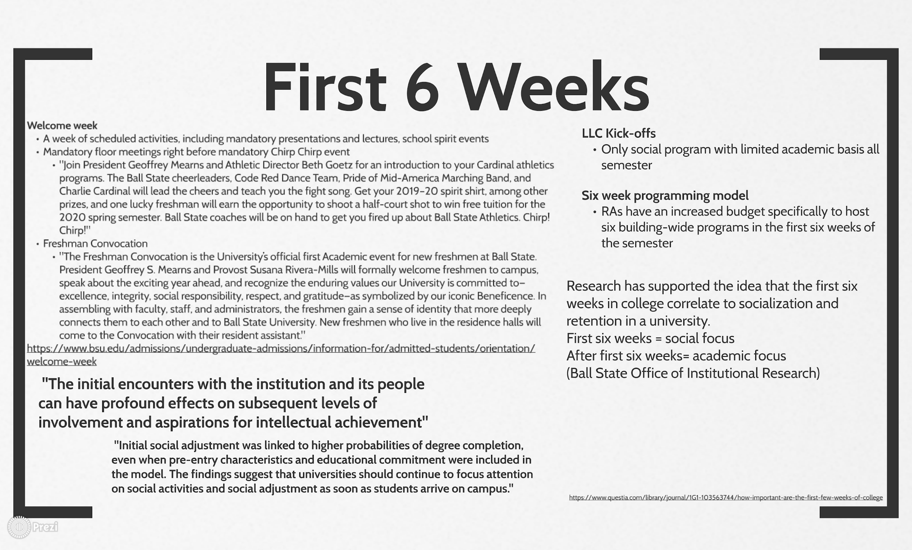
Figure 4
The first six weeks of a freshman’s college experience are paramount for all involved parties: freshmen will decide if they like and/or belong at the university; academic departments see course adds and drops; and Housing and Residence Life work to build a rapport between student staff members and their residents. All campus sects are working to strengthen a student’s connection to the university within the first six weeks because it directly correlates to an individual’s likelihood to remain at the university (Woosley).
As seen on the First Six Weeks slide of the timeline, multiple sources indicate the importance of a freshman’s first six weeks at college. Freshmen will be making a variety of decisions that become foundational for their social relationships, academic success, and rapport within their communities. To capitalize on this, and because of its relation to retention and graduation, Housing and Residence Life has implemented a six-week programming model. Each residence hall was given a budget outside of their semester programming funds for hall council, Resident Assistants, and Academic Peer Mentors for Living Learning Communities for RAs to plan and host a social program every week for the first six weeks of the semester.
At Housing and Residence Life events held by Hall Council, RAs, or APMs, staff members swipe student IDs and attendance is recorded by BennyLink, the event and organization database for Ball State. On a basic level, attendance numbers are used as a success metric for staff members to be evaluated by. However, higher level Housing and Residence Life employees use data collected from event attendance to track who attends building programs and to calculate interaction with residence hall communities in relation to retention. These numbers are used to justify HRL program funding and evaluate the effectiveness of student staff positions.
The Fall 2019 semester was the first semester in which this data was used to compile a distributed list of students who had not attended any building programs at the end of the six weeks. RAs and APMs were required to contact these residents to record an intentional interaction with them so that higher university figures had data on the residents. RAs and APMs are required to complete a specific amount of intentional interactions each week. This initiative is double sided: the university has data on residents to protect Ball State if a parent or guardian tries to blame the institution on a missing or deficient student, and residents benefit from feeling welcomed and cared about within their residence hall. The rapport and personal connection that residents gain from intentional interactions are another contributor to the likelihood of retention within the university. However, a student staff member’s motives for engaging with a resident is to complete another administrative aspect of their job, but residents are not aware of intentional interactions.
Recently, the majority of RAs in multiple residence halls were put on probation because of an uncommunicated expectation higher level Housing and Residence Life employees implemented that RAs document intentional interactions with all but two of their floor residents. The email from the Associate Director of Housing and Residence Life that informed RAs of their probationary status stated:
It is unacceptable that you have not submitted intentional interactions for every student given that the primary role of a resident assistance is to get to know each resident on his or her floor. This lack of intentional, face-to-face, interaction diminishes your role as a resource and role model. It can allow residents who need someone like you, to have a less than positive experience, to feel as if they are not connected or belong, and worse, to feel as if no one cares. You are being placed on resident assistant probation until May 4, 2020 (Ball State University).
Any responses would be ignored until the next day because the email was sent out at 5pm, the end of the workday. RAs feared for their jobs and were confused by the sudden disciplinary action that violates the disciplinary process of verbal warning, written warning, and then probation. When RAs reached out to their hall directors with their concerns and confusions, it was revealed that the expectation and sudden disciplinary action had also not been communicated to hall directors and assistant hall directors across campus.
The shock of this incident was a culmination brought on by the abrupt campus-wide emphasis on student staff interactions and programming within the first six weeks of the semester. There was no transition from the 2018-2019 school year’s programming model and expectations to those of Fall 2019. These changes and stringent initiatives were implemented in the same year that Housing and Residence Life is in a budget deficit. Hall directors no longer have $10,000 on their ID cards for laundry, and front desks are closed from 3am to 10am on weekends—instead of being open 24/7 like they previously were. Although I cannot support this with any official data, based on what I know about the way that HRL functions, this new emphasis could be a strategy to improve tangible statistics about the success of HRL, which would justify increased funding or assist in applying for grants to ease the budget deficit.
Midterm Deficiencies
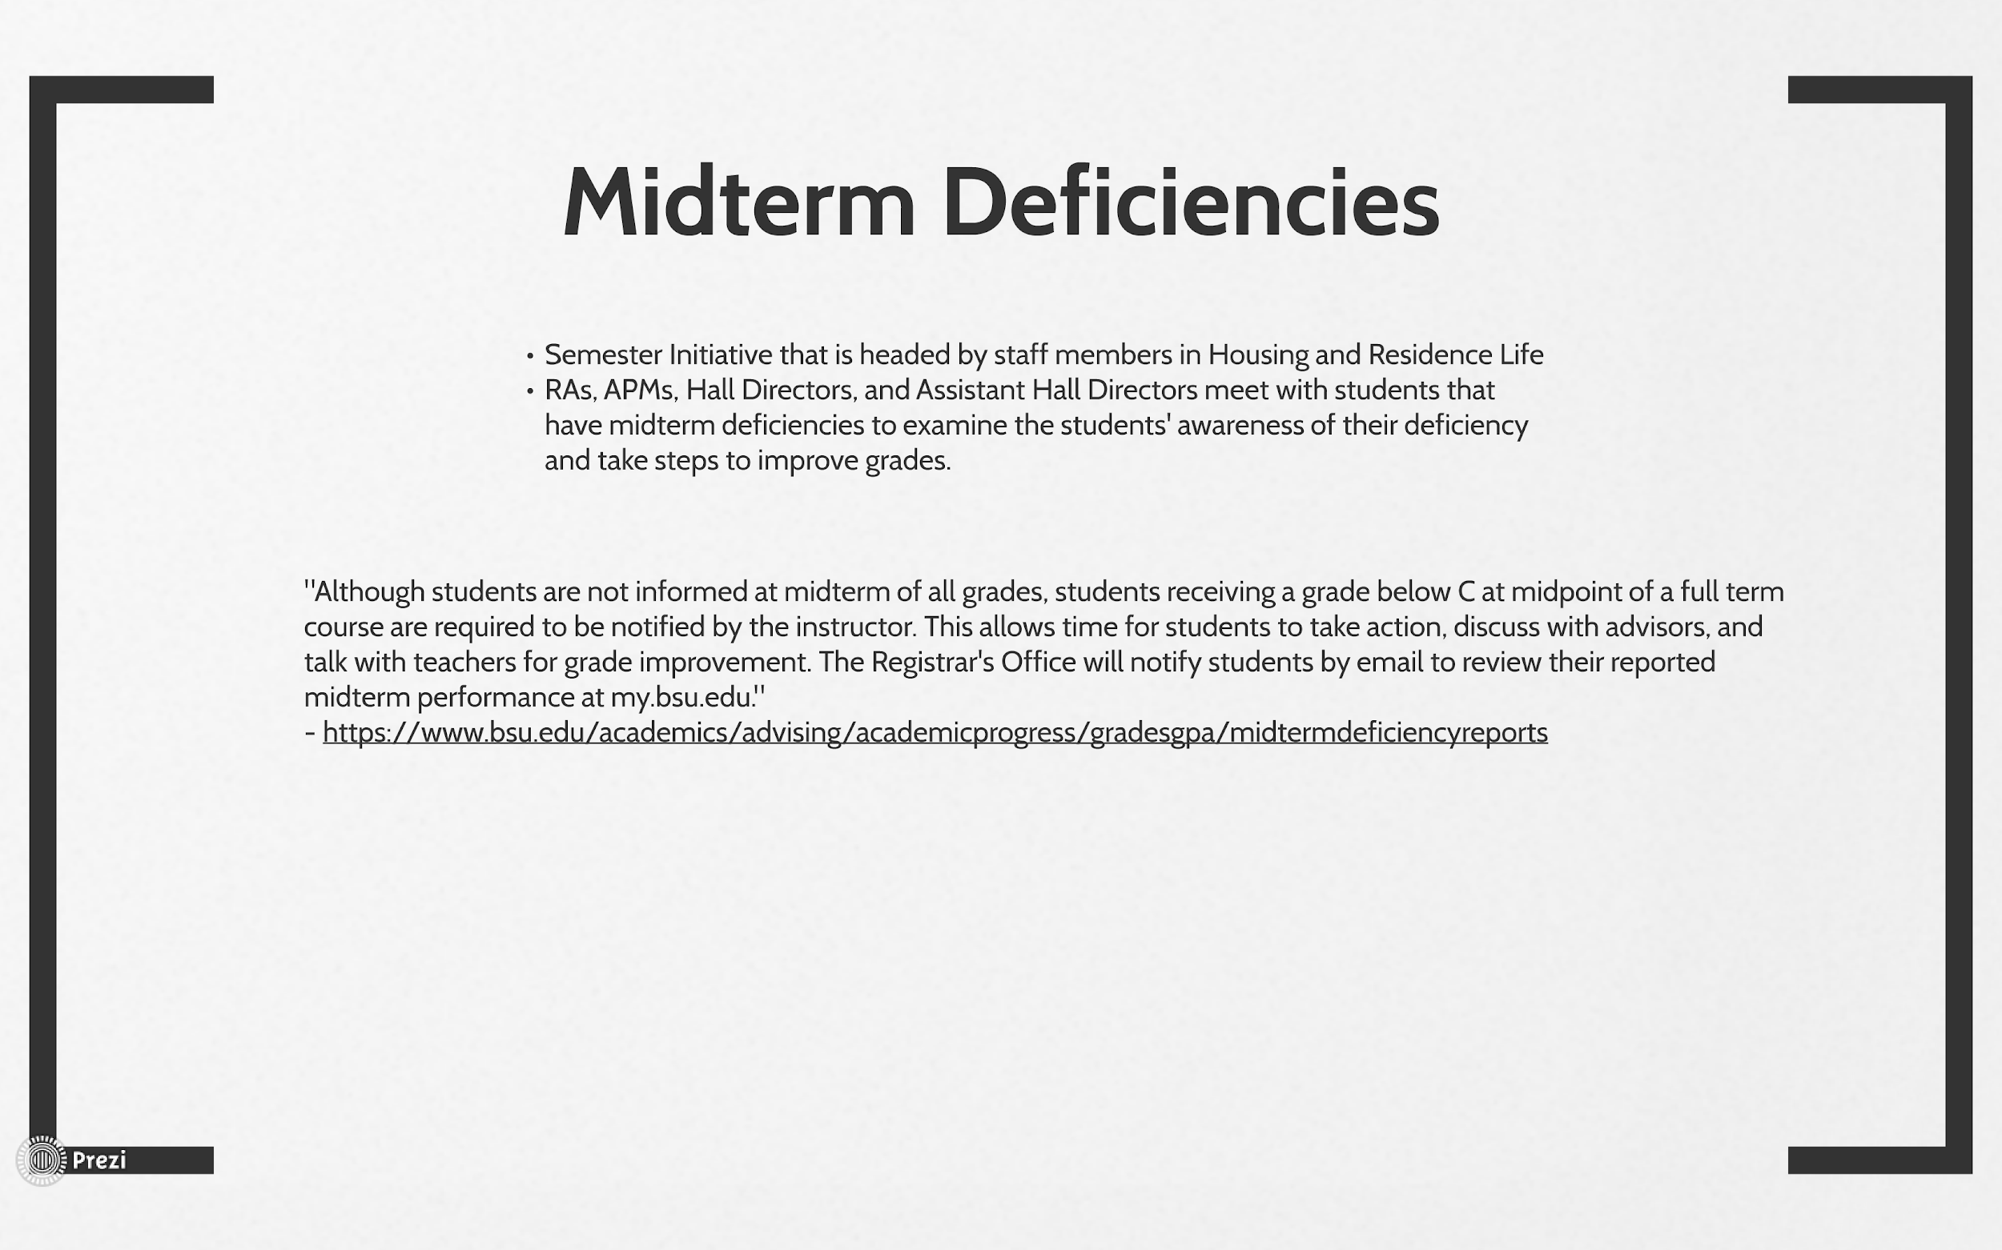
Figure 5
Midterm Deficiencies is an initiative that is facilitated primarily within Living Learning Communities. Academic Peer Mentors are given a confidential list of their residents that have a C-minus or lower in two or more courses. Hall Directors and RAs receive typically shorter lists of residents outside of the LLC, but APMs are the biggest asset in completing midterm deficiencies. Only higher level HRL administrators have access to the exact data, but when an APM discusses a resident’s midterm deficiencies, the resident is more likely to retain in the university and return to good academic standing within the university. APMs are meant to guide the discussion to evaluate whether or not a resident is aware of their deficiencies and help them compose a plan utilizing campus resources to improve their grades. Improving midterm deficiencies increases the average GPA of students that live on campus, a statistic that was heavily advertised when I was a freshman in 2017. Midterm deficiencies also have a direct correlation to retention. Students with midterm deficiencies are less likely to stay at Ball State and graduate because failing grades result in academic probation. While the effort to resolve midterm deficiencies benefits students, it is heavily emphasized because it produces effective data for the university to gain or maintain funding.
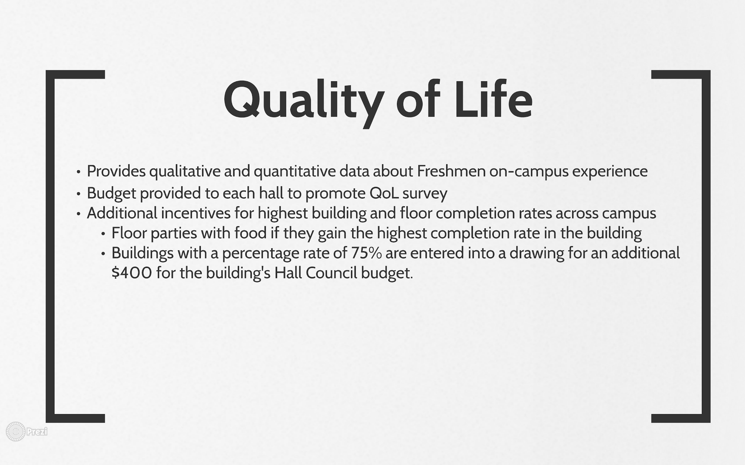
Quality of Life Survey Figure 6
HRL administrators collect quantitative data through attendance to track student GPAs and graduation rates in correlation to Living Learning Community and Residence Hall outcomes to provide tangible data on their success. The Quality of Life survey provides quantitative and qualitative data for analysts to support and strengthen other data. RAs and APMs are required to encourage residents to take it and promote the survey by using funds to purchase an incentive (typically food) to give to residents upon a resident’s proof of completion. Hall Councils provide a building-wide incentive for the floor with the highest completion rate in addition to the campus-wide incentive for the residence hall with the highest completion rate. Residents have an intrinsic motivation because their input can be used to effect change within the building regarding building matters, but questions about RAs, LLCs, APMs, sense of belonging, and academic comfort are used as program evaluation metrics. The Quality of Life Survey is another multifaceted implementation in HRL that benefits the program more than residents and contributes to the corporation parallel of the university by emphasizing student numbers instead of students themselves.
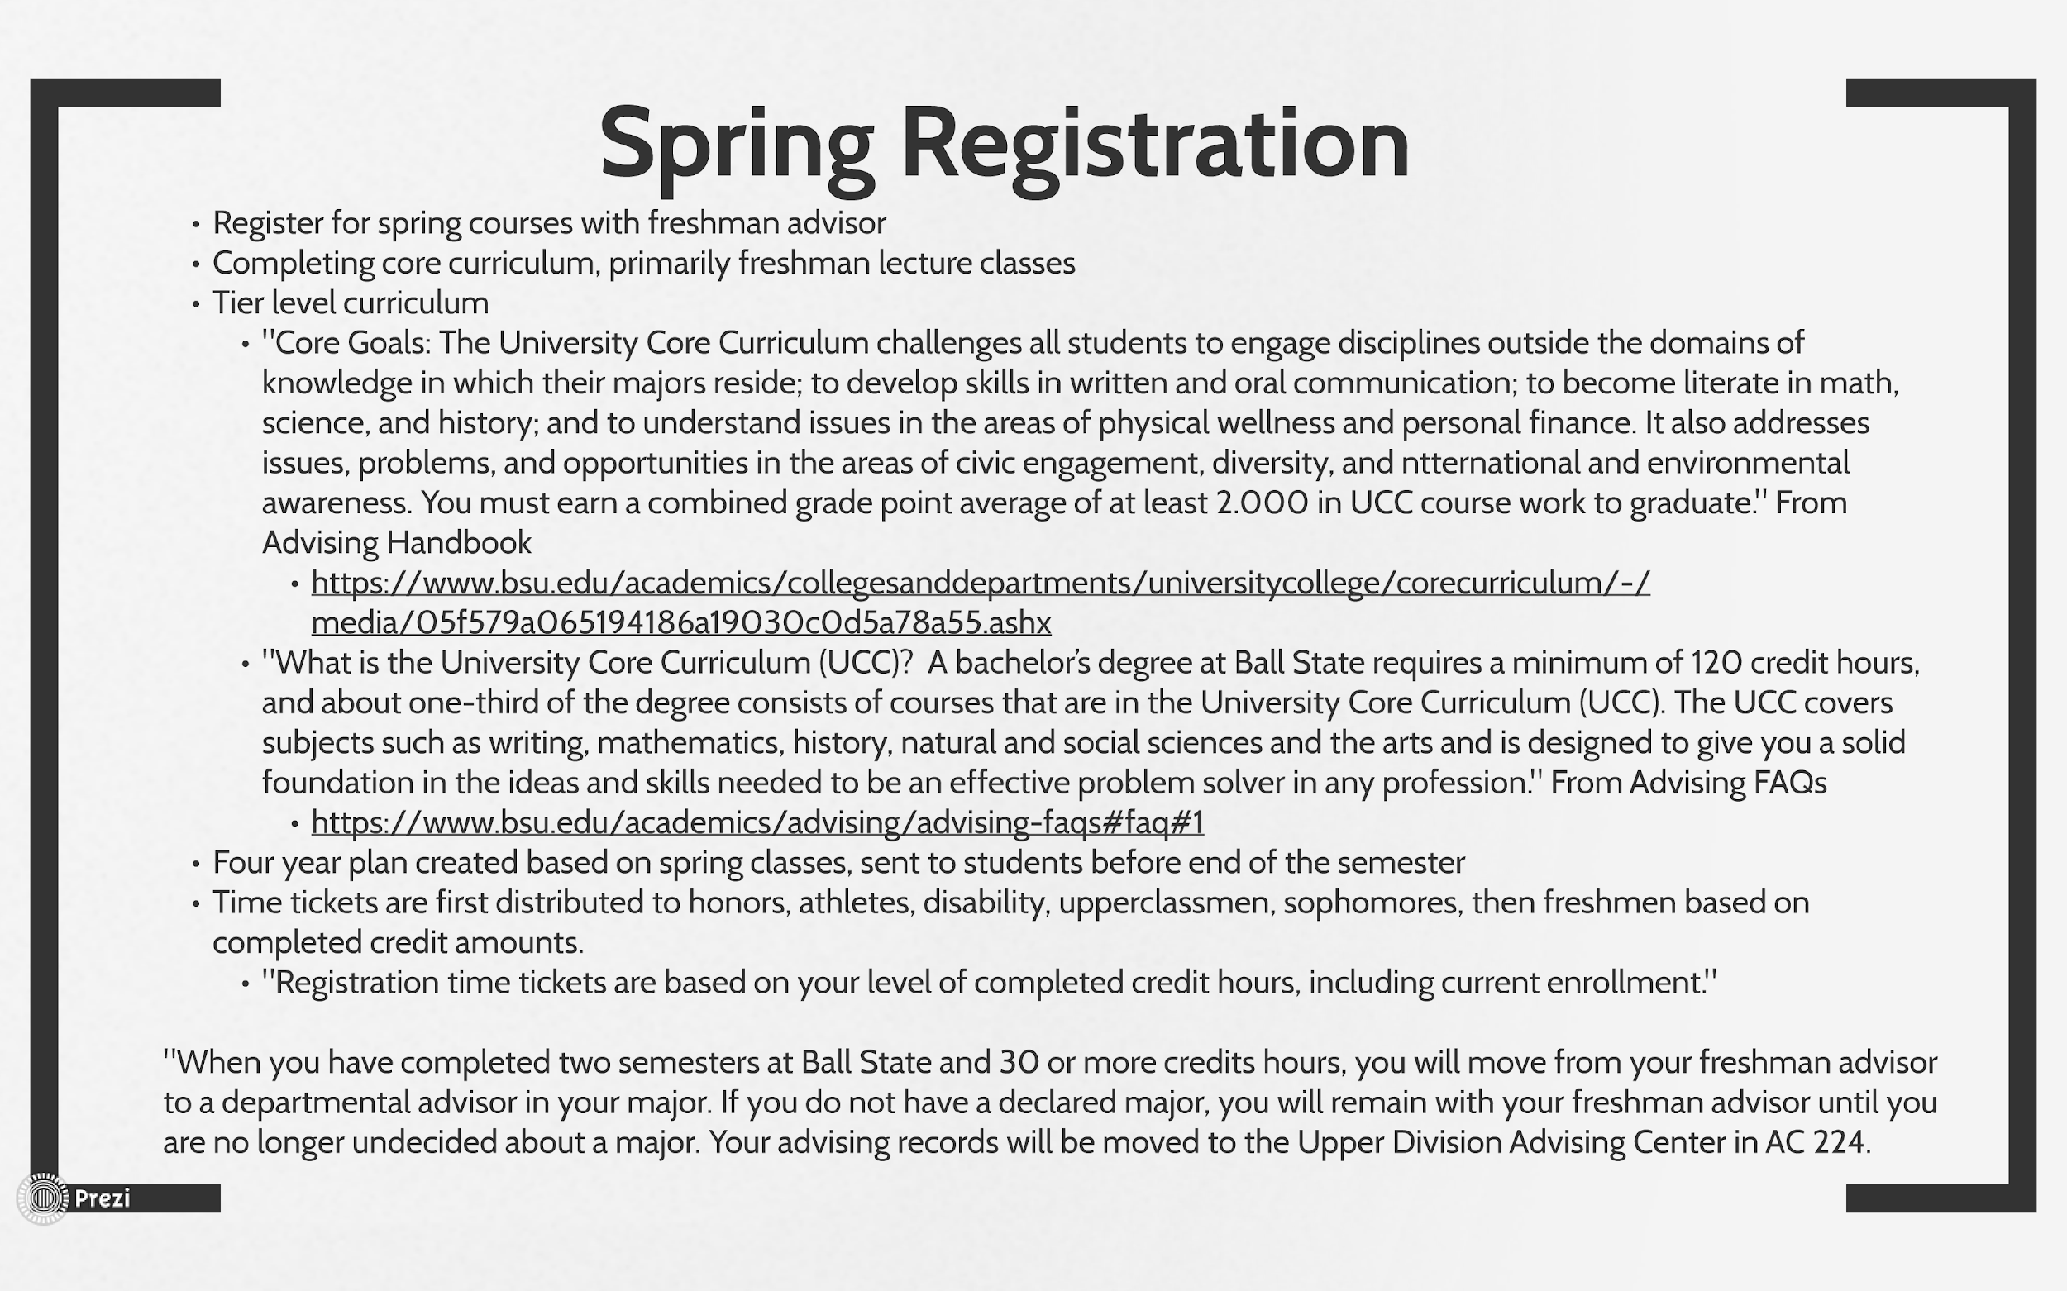
Spring Registration Figure 7
Similar to a freshman’s first advising appointment, advisors rigidly plan a student’s spring semester. The university’s three tier core curriculum distributes the education students receive across disciplines to achieve “well-roundedness.” Aside from the obvious monetary distribution to these departments for enrollment in core curriculum, these required general education courses add credit hours to a student’s degree progress. Without core curriculum, a student could potentially complete their degree in two years. The additional courses that are required by core curriculum require a student to stay at a university longer and, therefore, pay for more years of college. While core curriculum exists at every college and is not a hidden agenda, it holds enough prominence within the university to be mentioned.
Dorm Placement
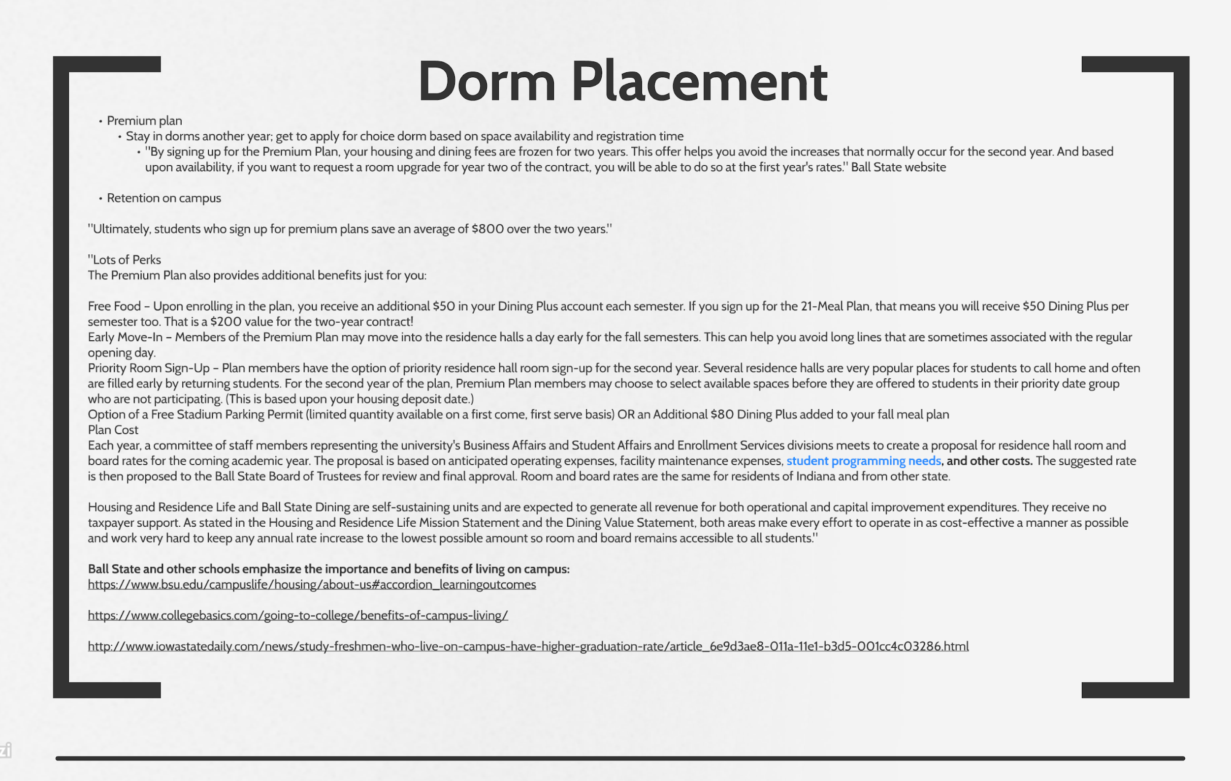Figure 8
Because data reveals that students living on campus have a higher GPA on average than students living off campus, and because of the income generator that residence halls are, Ball State adds incentives for on campus housing. Ball State and other schools emphasize the importance and benefits of living on campus, such as getting better grades and an increased likelihood of graduating.
The premium plan is one of the first things you learn about during campus tours and orientation. The premium housing plan boasts that you can live on campus for two years without being affected by potential cost inflation between the two years. Students that choose the premium plan also get an earlier time ticket to reserve a room in the residence hall of their choosing for their second year instead of getting randomly placed or a later time ticket that risks occupancy in a preferred hall. Ball State also includes the learning outcomes of Living Learning Communities on its website to entice students for on campus housing. Retention in the residence halls not only contributes to positive statistics about residence hall programs that are correlated to graduation, but it also generates more revenue because of the costs of room and board.
One of the most critical examples of the commercialization of the college experience at Ball State is listed on the slide where the cost is discussed.
Each year, a committee of staff members representing the University’s Business Affairs and Student Affairs and Enrollment Services divisions meets to create a proposal for residence hall room and board rates for the coming academic year. The proposal is based on anticipated operating expenses, facility maintenance expenses, student programming needs, and other costs (Ball State University).
The fact that the committee that decides the room and board cost includes business affairs and enrollment services—faculty members that directly engage with the fiscal management and acceptance of students—exemplifies the corporate aspect of the university. Such faculty members are included in room and board cost decisions because the data and information they have access to can be used to optimize the allocation of funds within room and board revenue. When the website says room and board is comprised of “student programming needs, and other costs”, it means the budget for Hall Councils, RAs, and APMs. “Other costs” is purposefully vague because the true breakdown of room and board costs would reveal the excessiveness of the fee and turn away prospective students and parents.
Application
Condemning Ball State because of its marketing and funding strategies would be incredibly naive and pointless. I chose to apply Deresiewicz’s concept of universities as corporations to Ball State because through my positions within the university, I realized that there are many factors that intentionally shape student life that students are completely unaware of, despite their direct involvement in such factors. I used this paper as a way to explore how the corporate model holistically affects a freshman and if Ball State relies on this model to an extent that exploits its students more than it educates them. Deresiewicz said,
The customer-service mentality is also responsible for the profusion of swanky new dorms, gyms, and student centers—a building boom that, like the other ones that happened in the 1990s and early 2000s, was financed by a mountain of debt, and that has been a major factor in tuition growth. Colleges now sell themselves to kids in terms of what they can give them, not what they plan to expect of them (69).
Of course modern universities have to adapt to a model that resembles corporations and consumerism because of systematic foundations for university funding, but at what point are universities more factories than facilitators? Modern students have adapted to and accepted the steep inflation of tuition costs because the incentive of having a job with a livable wage is a necessity. Has the corporation-consumer model become mutual? Perhaps there is not too much of a moral quandary for the relationship between a university and its students because of modern society’s demands.
An investigation of the ethics of a university’s corporate manipulation of students is futile if people want nothing more from their college experience than a degree for a job in their chosen career field. However, traditional colleges were founded with higher expectations. Deresiewicz recognizes the potential shift in student expectations in Excellent Sheep.
But the worst effect of the commercialization of higher education is the way that it has changed how institutions see their students. Now they think of them as “customers,” people to be pandered to instead of challenged. The customer-service mentality is also responsible for the profusion of swanky new dorms, gyms, and student centers—a building boom that, like the other ones that happened in the 1990s and early 2000s, was financed by a mountain of debt, and that has been a major factor in tuition growth. Colleges now sell themselves to kids in terms of what they can give them, not what they plan to expect of them (69).
The most relevant data that I found in the 2018 Financial Report directly coincides with this idea as it outlines recent costs, campus initiatives, and their funding. 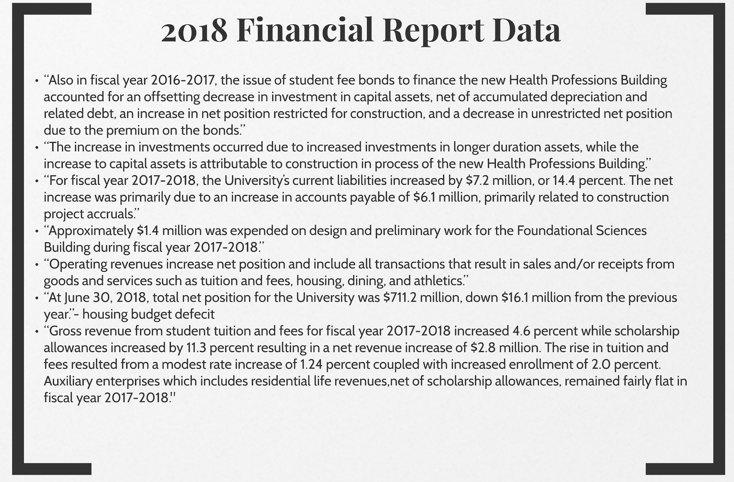
Even if Ball State students are paying tens of thousands of dollars toward the new Foundational Sciences Building and Residence Hall One, perhaps a degree and “free” use of the recreation center are worth it for them. Perhaps new students are coming into their freshman year expecting this experience. All colleges could be using this model and all students could be content with it; so then why is that idea so unsettling? Deresiewicz provides another alternative that supports my own feelings: we should expect more from universities.
Yet a commercial relationship is exactly the opposite of a pedagogical one. You give your customer what they want, but you don’t have any interest in their long-term welfare. It is precisely because you do have an interest in your students’ long-term welfare that you don’t give them what they want… Teaching, said Socrates, is the reeducation of desire… Professors should be mentors, not commodities or clerks. Education isn’t something you consume; it’s an experience that you have to give yourself over to (69).
If students are equally as complacent in this corporate university model as the institutions are, society and educational expectations are fundamental in managing the consumerist relationship between the two. However, if students are still looking to gain more from their college experience than just a degree—like something closer to the “reeducation of desire” that Socrates suggests—then we have a scale with which to evaluate Ball State’s model.
I have been pleased with my education at Ball State because it exceeds my courses’ curriculum. Ball State has provided me with many opportunities for introspection, personal growth, and interdisciplinary learning. Whether that is confined to the Humanities department or an individual path that is not included in university core curriculum is unbeknownst to me. What I do know is that colleges should facilitate education that transcends learning outcomes while working to provide optimal campus experiences. I have no solution to provide a metric to gauge this at universities, and clearly Ball State would have to maintain its corporate model to sustain its ability to provide an education to students because all institutions function this way now. However, I am a Humanities student, so I can only hope that this corporate model includes a supply and demand relationship in which students demand more from their education, and universities supply it.

Sources
“About Housing and Residence Life.” Ball State University, www.bsu.edu/campuslife/housing/about-us#accordion_learningoutcomes.
“Advising FAQs.” Ball State University, www.bsu.edu/academics/advising/advising-faqs#faq#1.
“Advising Handbook.” Ball State Advising Handbook, www.bsu.edu/-/media/www/departmentalcontent/advising/2019-2020%20advising%20handbook.pdf?la=en&hash=BC5F98B835ABCF8C5BD707BD2486C8AABDA7B4D2 .
CollegeBasics. “The Benefits of Living on Campus.” CollegeBasics, 11 Apr. 2018, www.collegebasics.com/going-to-college/benefits-of-campus-living/.
Coppock, Erin. “Study: Freshmen Who Live on Campus Have Higher Graduation Rate.” Iowa State Daily, 30 Oct. 2011, www.iowastatedaily.com/news/study-freshmen-who-live-on-campus-have-higher-graduation-rate/article_6e9d3ae8-011a-11e1-b3d5-001cc4c03286.html.
Deresiewicz, William. Excellent Sheep: the Miseducation of the American Elite and the Way to a Meaningful Life. Free Press, 2015.
Hannon, Bernard M. “2018 Financial Report.” Ball State 2018 Financial Report, 30 June 2018, www.bsu.edu/-/media/www/departmentalcontent/factbook/1819pdfs/2018%20financial%20report%20final112918.pdf?la=en&hash=157DF103311A1B6580699A71DA872A1A595D1C39 .
Matthews, Bryan. “Retention Matters.” Inside Higher Ed, 2 Nov. 2009, www.insidehighered.com/views/2009/11/02/retention-matters.
Mechem, Brynn. “Ball State Releases Its New Brand Slogan.” Ball State Daily, 6 Nov. 2017, www.ballstatedaily.com/article/2017/11/news-new-brand-slogan.
“Midterm Deficiency Reports.” Ball State University, www.bsu.edu/academics/advising/academicprogress/gradesgpa/midtermdeficiencyreports.
“Test-Optional Information.” Ball State University, www.bsu.edu/admissions/undergraduate-admissions/information-for/high-school-students/test-optional.
“Undergraduate Orientation.” Ball State University, www.bsu.edu/admissions/undergraduate-admissions/information-for/admitted-students/orientation.
“Welcome Week at Ball State.” Ball State University, www.bsu.edu/admissions/undergraduate-admissions/information-for/admitted-students/orientation/welcome-week.
Woosley, Sherry A. “How Important Are the First Few Weeks of College? the Long Term Effects of Initial College Experiences.” College Student Journal, Project Innovation, 1 June 2003, www.questia.com/library/journal/1G1-103563744/how-important-are-the-first-few-weeks-of-college.

